**Sports Management System**

**Software Requirements Specification**

**CEN 3031 Fall 2018**

**Modification history:**

|  |  |  |  |
| --- | --- | --- | --- |
| Version | Date | Who | Comment |
| v1.0 | 10/16/18 | Jake, Andrew, Jordan S, Jordan M, Guilherme, Gregorio | This is the first version of our software |
| ... |  |  |  |

**Team Name:** Active364

**Team Members:**

* Andrew Wilson abwilson5729@eagle.fgcu.edu
* Jake Sherman jmsherman9253@eagle.fgcu.edu
* Jordon Sasek jsasek5815@eagle.fgcu.edu
* Jordon Moses jmmoses2190@eagle.fgcu.edu
* Guilherme Pereira grpereira1714@eagle.fgcu.edu
* Gregorio Lozada gjlozdada8704@eagle.fgcu.edu

**Contents of this Document**

Introduction

* Software to be Produced
* Definition, Acronyms, and Abbreviations

Product Overview

* Assumptions
* Use Case Diagram
* Use Case Descriptions

Specific Requirements

**SECTION 1: Introduction**

Software to be Produced:

* The software being produced is a sports league management system. Users can create account of different tiers consisting of spectator, team player, and team managers. Spectators, players and managers can follow teams and be notified of their upcoming events, players can request to join teams, and managers can accept players into their team, set up events, and update their team’s scores.

Definitions, Acronyms, and Abbreviations:

* None

**SECTION 2:** **Product Overview**

Assumptions:

* The system assumes users will have a computer.
* The system assumes users will run Microsoft Windows.
* The system assumes users will speak English.
* We assume that the user will only handle with our program on their computer and not on a mobile device such as phones or tablets.
* We assume that the user’s purpose in using our application is to view the current scores of a team playing or to make a post for others to see.
* We assume the that the computer the user has will have a minimum of 1GB – 2 GB of memory (RAM) to run our program.
* We assume the computer will have at least above 15% of free space for the program to function properly.
* We assume this product be implemented as a COTS (commercial-off the shelf) product for consumers to use at their disposal.

Use Case Diagram: (Next Page)

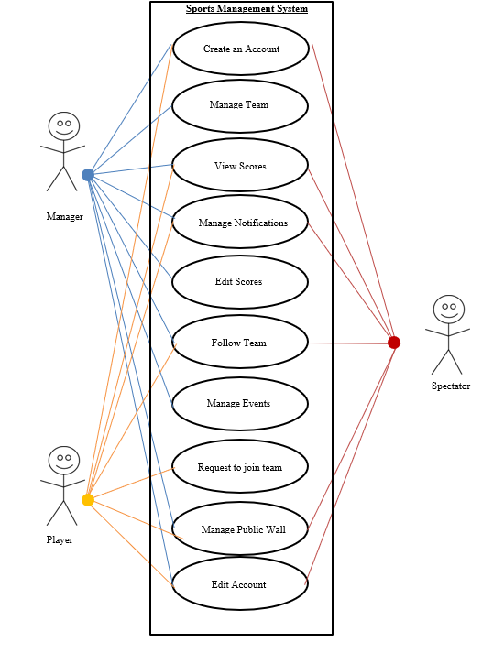

Use Case Descriptions:

* **Create an Account:** Choose between Manager, Player, or Spectator to gain access to different areas of the system.
* **Manage Team:** A manager can access this part of the system to manage their team and accept join requests from players that wish to join the team.
* **View Scores:** Any user can view scores from games played.
* **Manage Notifications:** Any user can change their notification settings.
* **Edit Scores:** A manager can edit the score of games.
* **Follow Team:** Any user can choose to follow a favorite team.
* **Manage Events:** A manager can create, delete, and edit events that will take place.
* **Request to join team:** A player can send a request to a manager to join a team.
* **Manage Public Wall:** Any user can post on their wall along with view and comment on others threads.
* **Edit Account:** Any user can edit their account information including changing their level. (Manager, Player, Spectator)

**SECTION 3: Specific Requirements**

|  |
| --- |
| **No:** 1 |
| **Statement:** The system shall incorporate account creation using user’s names, a username, and password. |
| **No:** 2 |
| **Statement:** The system shall allow users to login into their accounts with their username and password. |
| **No:** 3 |
| **Statement:** The system shall keep team scores. |
| **No:** 4 |
| **Statement:** The system shall hold accounts for team managers, team players, and spectators. |
| **No:** 5 |
| **Statement:** The system shall allow spectators to follow teams and view their upcoming events. |
| **No:** 6 |
| **Statement:** The system shall allow team players to request to join teams. |
| **No:** 7 |
| **Statement:** The system shall allow team managers to set up events for their team with date, time, and location. |
| **No:** 8 |
| **Statement:** The system shall allow team manager to edit the date, time, and location for their team’s events. |
| **No:** 9 |
| **Statement:** The system shall allow team managers to set up teams and accept members. |
| **No:** 10 |
| **Statement:** The system shall allow team managers to update team scores. |
| **No:** 11 |
| **Statement:** The system shall allow users to upload text or images onto a public wall or team wall. |
| **No:** 12 |
| **Statement:** The system shall incorporate a calendar system to mark the current date and future events. |
| **No:** 13 |
| **Statement:** The system shall provide a “news feed” consisting of new events, and new team members depending on who the user is following. |
| **No:** 14 |
| **Statement:** The system shall allow users access their favorite sports on a quick access bar. |
| **No:** 15 |
| **Statement:** The system shall allow users to comment on posts for games. |
| **No:** 16 |
| **Statement:** The system shall allow users to change their account tier from spectator to player, or manager. |
| **No:** 17 |
| **Statement:** The system shall notify users of events for teams they are following a week before it’s date. |
| **No:** 18 |
| **Statement:** The system shall notify users of events for teams they are following a day before it’s date. |
| **No:** 19 |
| **Statement:** The system shall allow users to turn notifications on or off for an upcoming event. |
| **No:** 20 |
| **Statement:** The system shall display team scores for ongoing events. |

Template created by G. Walton ([GWalton@mail.ucf.edu](mailto:GWalton@mail.ucf.edu)) on Aug 30, 1999 and last updated Aug 15, 2000; updated by A. Koufakou, Aug 2014

This page last modified by Jake Sherman (<mailto:jmsherman9253@eagle.fgcu.edu>) on 10/16/18